# CS 255 System Design Document Template

This template lays out all the different sections that you need to complete for Project Two. Each section has guidance to prompt your thinking. You will need to continually reference the interview transcript as you work to make sure that you are addressing your client’s needs. There is no required length for the final document. Instead the goal is to complete each section based on what your client’s needs are. Remove this note when you are finished, and replace all bracketed text with the relevant information.

## UML Diagrams

### UML Activity Diagrams

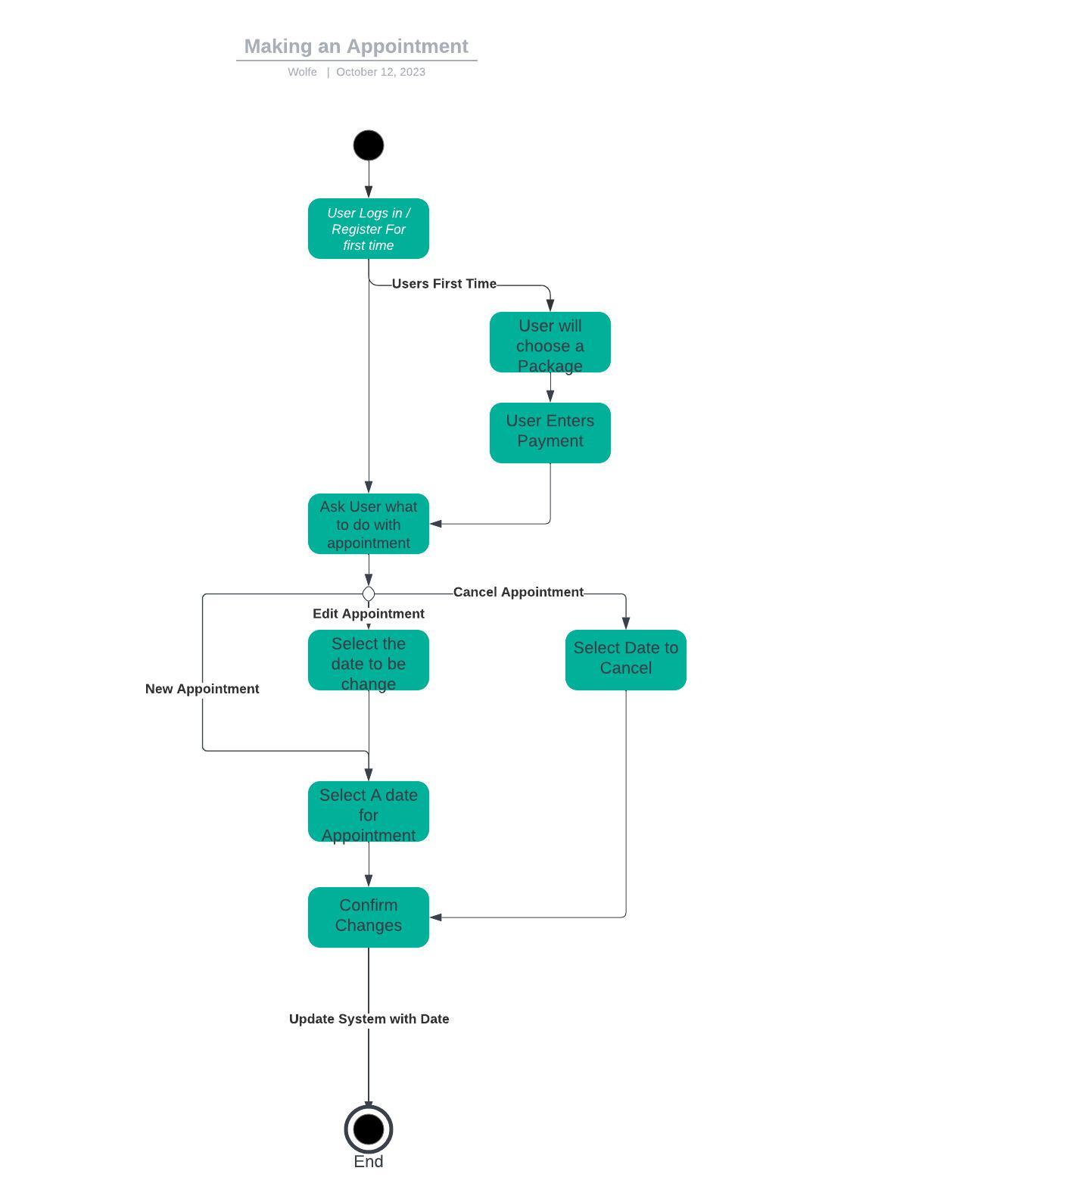

### UML Sequence Diagram

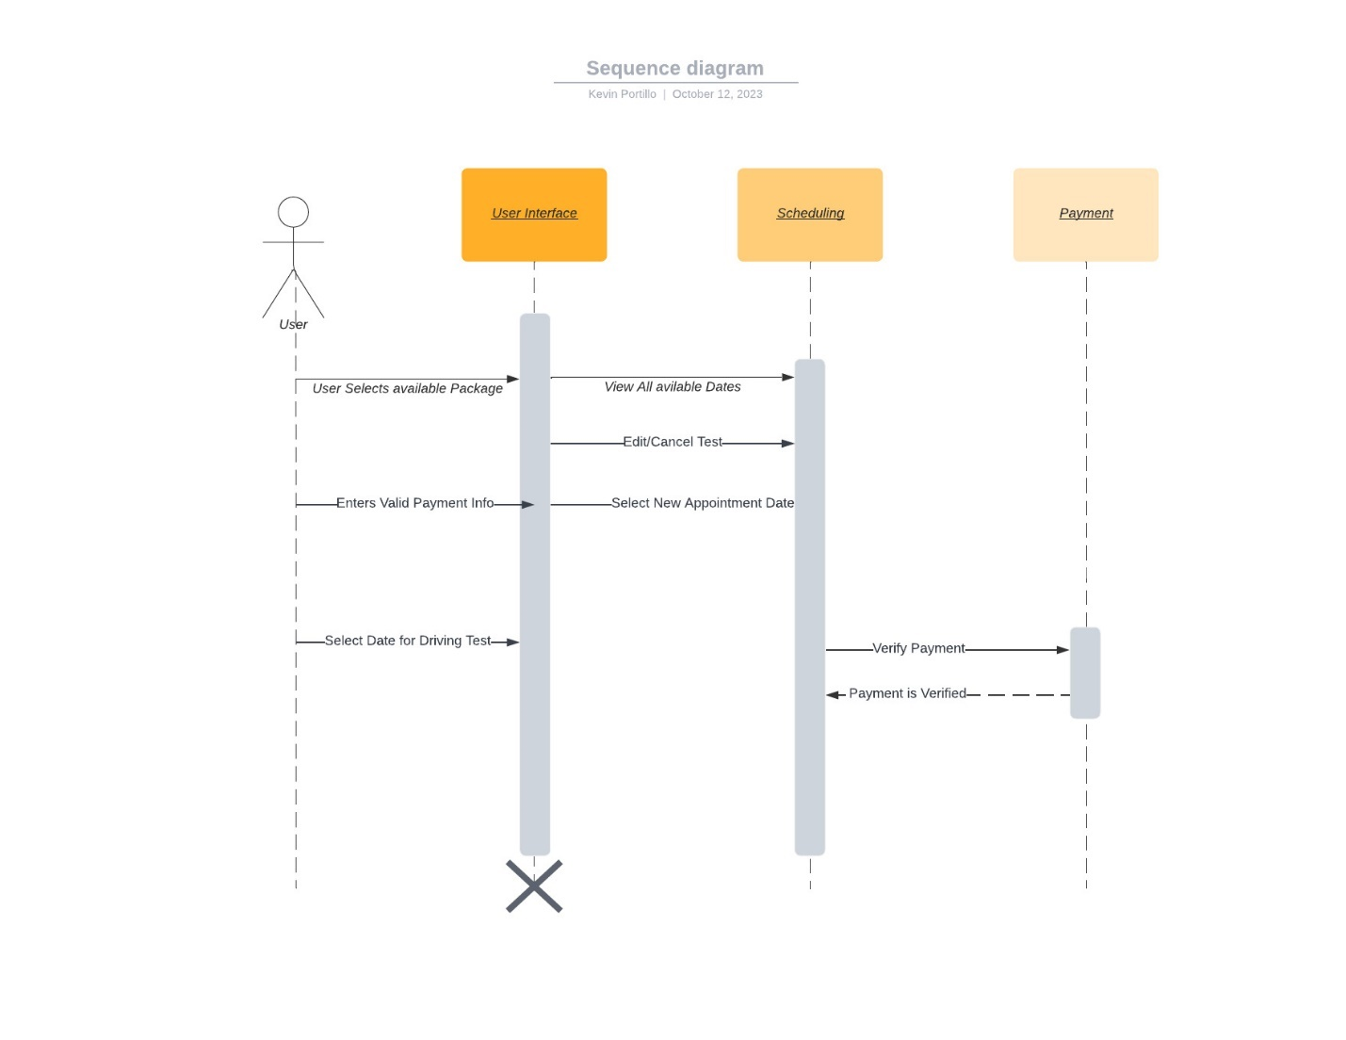

### UML Class Diagram

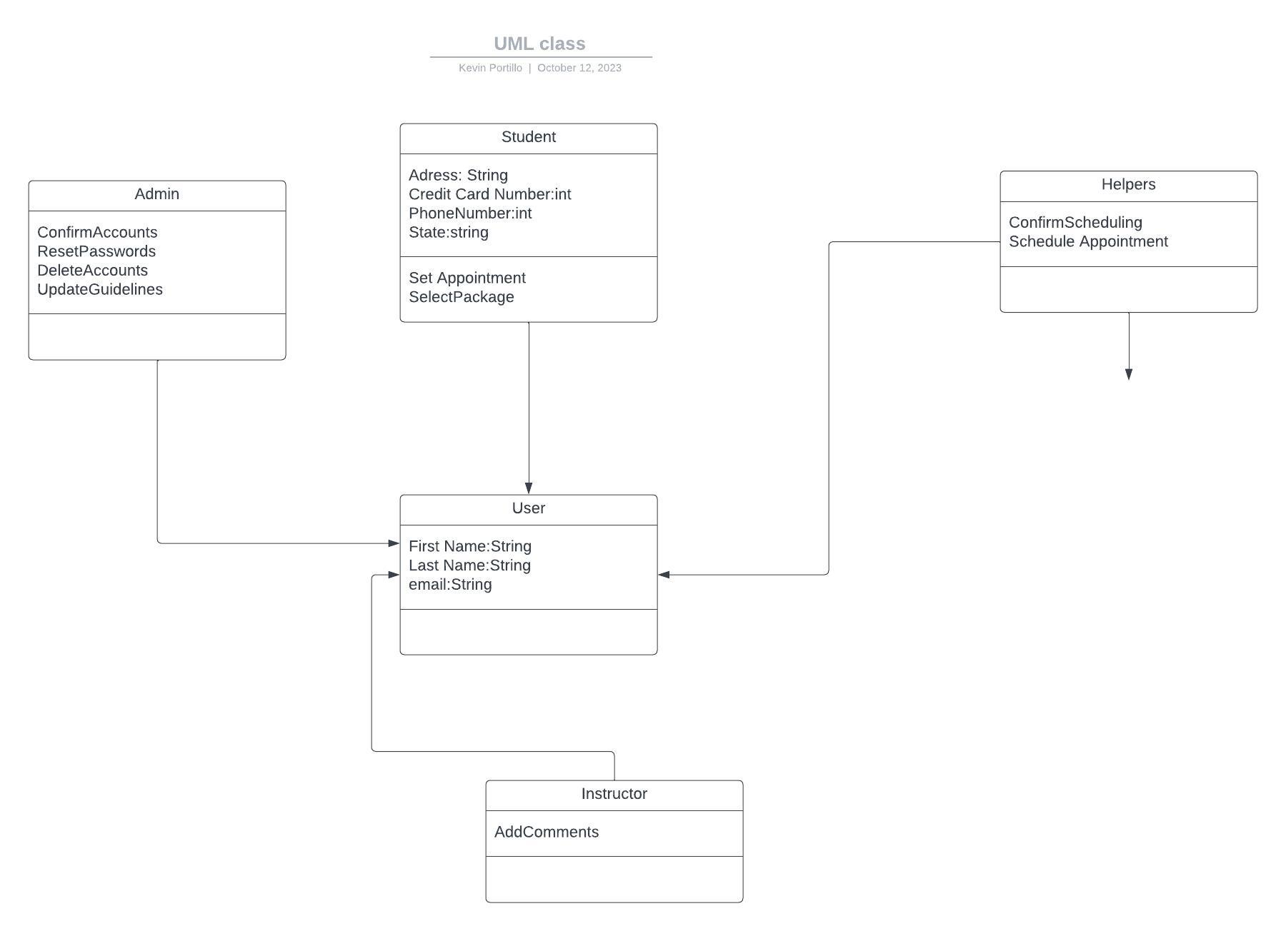

## Technical Requirements

*The requirements to run the project we will need to be able to handle many requests coming from the user. There must be a server that will be able to save everyone’s information. There must be a system that will validate the payments for the packages we will sell to them. There must be a tool that will be able to securely log in users and if the user forgets their password, they will be able to retrieve. Users will need to be able to communicate with support and/or instructors.*